*A Mini Project Report on*

**e-Real Estate Management System**

**S.E. - I.T Engineering**

**Submitted By**

**Madhu Gage 20104037**

**Amir Madoo 20104013**

**Darpan Mhatre 20104019**

**Manashree Chavan 20104028**

**Under The Guidance Of**

**Prof. Vishal Badgujar**



**DEPARTMENT OF INFORMATION TECHNOLOGY**

A. P. Shah Institute of Technology

G.B. Road, Kasarvadavali, Thane (W), Mumbai-400615

UNIVERSITY OF MUMBAI

**Academic year: 2021-22**

**CERTIFICATE**

This to certify that the Mini Project report on e-Real-estate Management System has been submitted by Madhu Gage (20104037), Amir Madoo (20104013), Darpan Mhatre (20104019), and Manashree Chavan (20104028) who are a Bonafide students of A. P. Shah Institute of Technology, Thane, Mumbai, as a partial fulfilment of the requirement for the degree in Information Technology, during the academic year 2021-2022 in the satisfactory manner as per the curriculum laid down by University of Mumbai.

Mr Vishal Badgujar

Guide

Prof. Kiran Deshpande Dr.Uttam. D. Kolekar

Head Department of Information Technology Principal

External Examiner(s)

1.

2.

Place: A.P Shah Institute of Technology, Thane

Date:

**ACKNOWLEDGEMENT**

This project would not have come to fruition without the invaluable help of our guide **Mr**. **Vishal Badgujar** Expressing gratitude towards our HoD, **Prof. Kiran Deshpande**, and the Department of Information Technology for providing us with the opportunity as well as the support required to pursue this project. We would also like to thank our teacher **Ms. Anagha Aher** who gave us her valuable suggestions and ideas when we were in need of them. We would also like to thank our peers for their helpful suggestions.

**TABLE OF CONTENTS**

|  |  |  |
| --- | --- | --- |
| Sr.no. | Contents | Page no. |
| 1. | Introduction | 1 |
|  | 1.1 Purpose | 1 |
|  | 1.2 Objectives | 1 |
| 2. | Problem Definition | 2 |
| 3. | Proposed System | 3 |
|  | 3.1 Features and Functionality | 4 |
| 4. | Project Outcomes | 5 |
| 5. | Software Requirements | 6 |
| 6. | Project Design | 7 |
| 7. | Implementation | 9 |
| 8. | Result | 13 |
| 9. | Project Scheduling | 17 |
| 10. | Conclusion | 18 |
|  | References |  |

# Chapter 1

**Introduction**

Real estate is a type of business for selling, buying, renting flats, shops and offices. Many individuals look for property for a variety of reasons. Every individual wants his house to be in the best location with best facilities. Offices and shops should be near market area in order to increase sales and productivity. The manual real estate agency follows a lengthy and hectic process. People need to meet the agent in person, for checking the Property details and also needs to visit the location every time. It takes long time to look for the desired location and desired type of property. Thus, we have proposed an online real estate management system. This online Property Management system can help you to get best property by just sitting at home or anywhere. In this system the agent or the Owner himself can add the property for selling/ renting purpose and users can buy or book a property for rent.

**1.1 Purpose:**

The purpose of our application is to help people to find their dream home with just a few clicks, to make properties available on their fingertips. User can directly search for the properties in any city rather than personally visiting there. The application has a variety of functionalities like selling, buying, searching a property for residential or commercial purpose. Users need to register and then login just by using credentials.

* 1. **Objectives:**
* To create an environment with good user experience for both the consumer and seller.
* To have client’s better visibility.
* To have better marketing.

**Chapter 2**

**Problem Definition**

We all have those times when we have to migrate from one place to another in search of job, Job transfer, or any other reason. Shelter is not just an essential thing but a place where we live and create some beautiful moments and make home out of an empty box of walls. Visiting different places every day for a working person or a person living far away from that place is very much time consuming as well as sometimes not possible. If a person wants to sell his flat or a bungalow, he/she cannot go looking for people interested in the same or rely on any agent. Now, looking from commercial point of view, if someone is looking for a place to start a business located in the city centre or a person wants to rent his property for rent or sell here, our application can be of great use. Interested person can contact the owner and get the rest of details. User can add his details, type of property he/she is interested in and property information in our database.

**Chapter 3**

**Proposed System:**

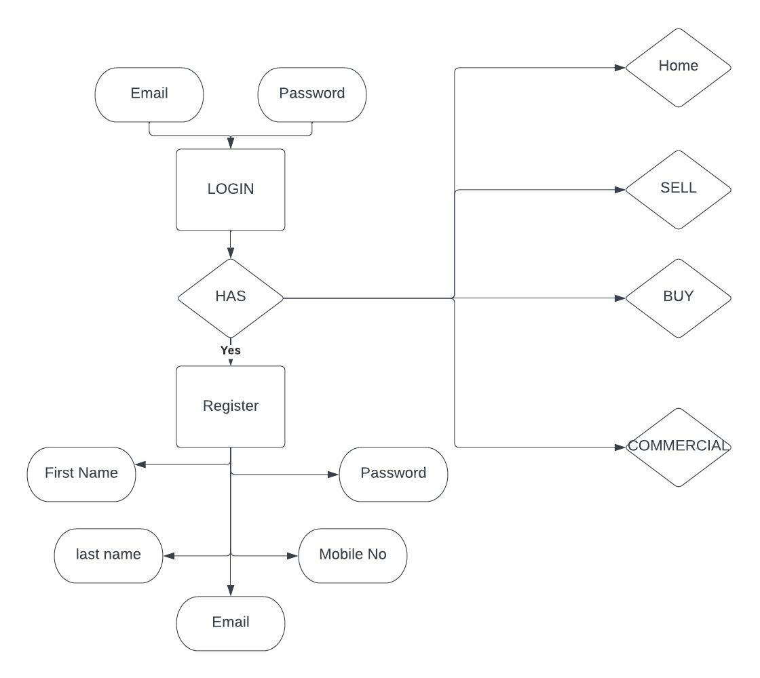

**Fig 3.1 Registration**

**Register:** First-time users can register by entering all of their information, including their first and last names, e-mail addresses, phone numbers, and passwords, in order to log in the next time.



**Fig 3.2 Login**

**Login:** The user can log into our system as many times as he or she wants using his or her email address and password.

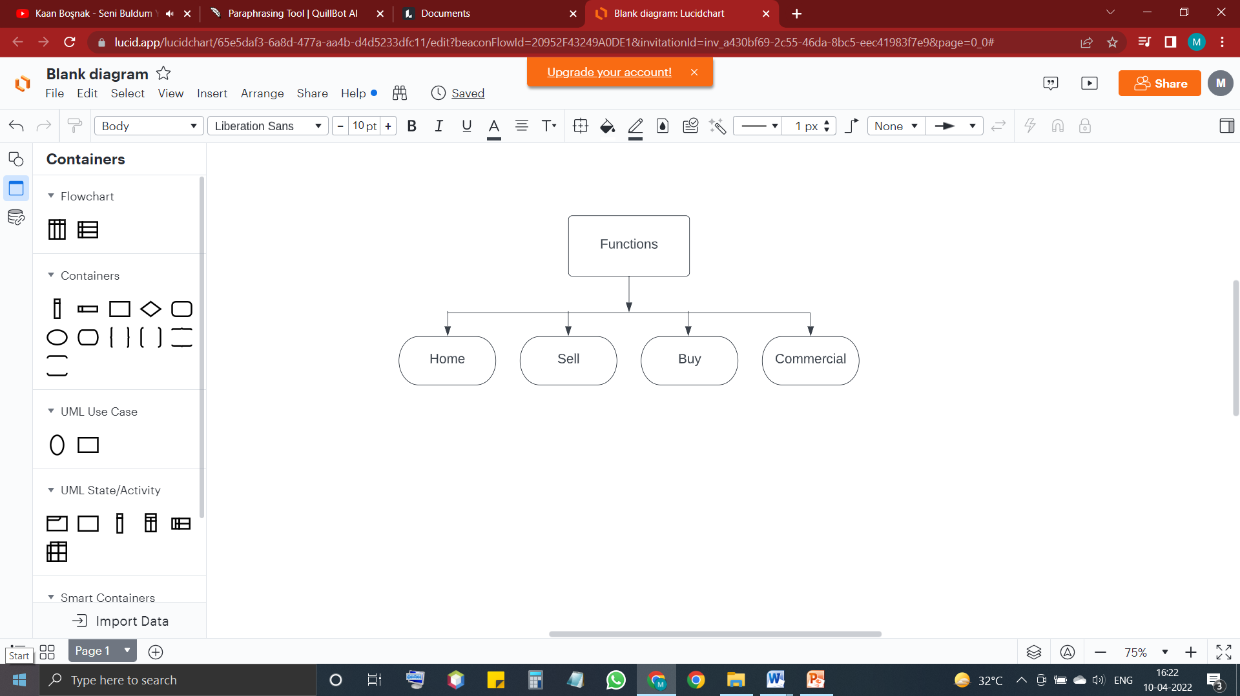

**Fig3.3 Functionalities**

**Functionalities:** Once a user has logged in he/she can view properties and search option in home page. In Sell property page, user can upload his property details. Buy page shows the properties in which user is interested and the commercial page shows the available commercial properties.

**3.2 Features and Functionality:**

**Modules**

1. Register Module: Used for managing the details of the user for the first time
2. Login Module: Used for managing the login details
3. Home Module: Used to view liked properties and user profile
4. Sell Property Module: Used for adding the property by user
5. Buy Property Module: Used for viewing the properties
6. Search Module: Used for managing the searched properties
7. Commercial Module: Used for viewing rental shops
8. Logout Module: Used for managing logout details

**Features:**

1. Takes details from the user while registration for avoiding data errors
2. Provides a login option for using the application many times
3. User can add their properties for sale
4. User can buy or rent property
5. Search option helps to get the desired property
6. Removal of third party and have user to user interaction

# Chapter 4

**Project Outcome:**

1. User has to register for the first time.
2. User then can login after registration at any time of his/her choice.
3. User can add Property for sale or rental purpose.
4. User can also edit their property.
5. Search option will display the property in the desired location.
6. Users will also be able to view other available properties.
7. E-Real-estate Management displays detailed information and amenities about all the properties, with landmarks and owner details.
8. Lastly, logout option is available for user to exit.

# Chapter 5

**Software Requirements:**

1. **Front End**:

Tkinter is used for front end designing

1. **Back End:**

SQLlite3 is used for data base connectivity

1. **IDE:**

Visual Studio, Pycharm &Python Idle are used for source code

1. **Operating System:**

Windows11

# Chapter 6

**Project Design:**

**Register:**

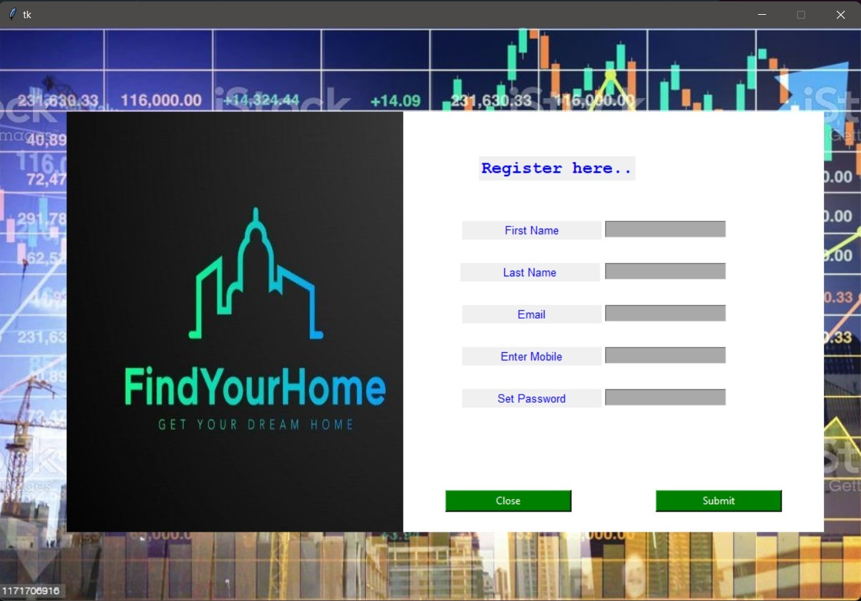

**Fig 6.1**

First time user should register to our page by filling all the required details that is name, email, mobile number and password. for logging in next time user will only require user name and password.

**Login:**

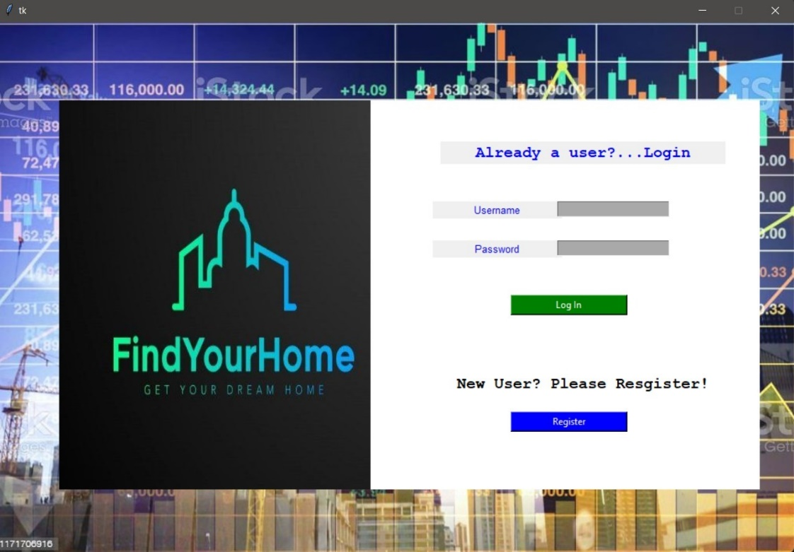

**Fig 6.2**

Already registered user should login by putting on user id and password which will take them to our Home page. Once user is logged in he/she can sell his property or view any property

# Chapter 7

# Implementation:

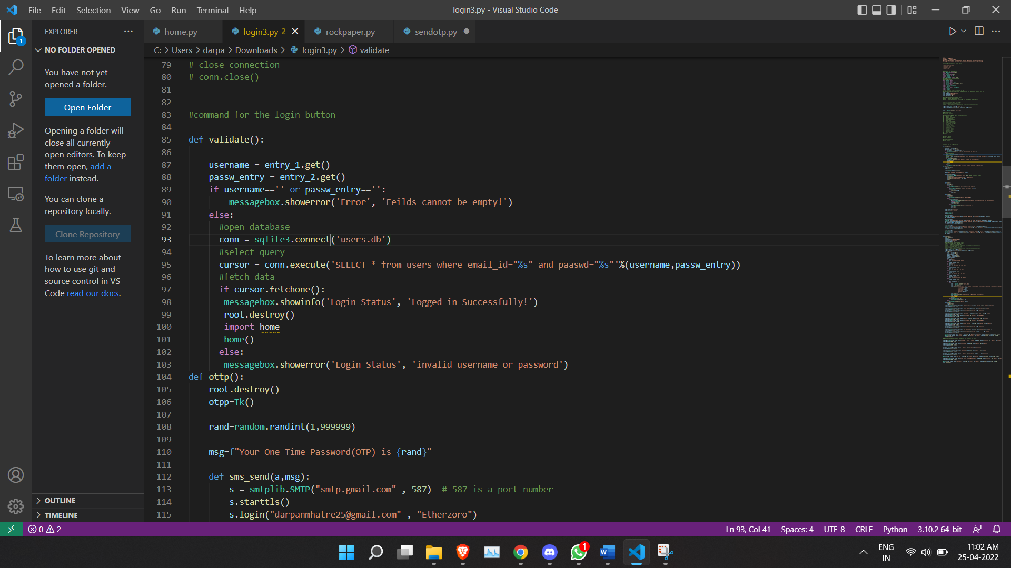

**Fig 7.1 Login Code**

Here, we have used if statement. If the username or password is incorrect a pop up message will occur saying incorrect userid or password. Data will get fetched from database and if user puts correct credentials, the user will be logged in in our application.

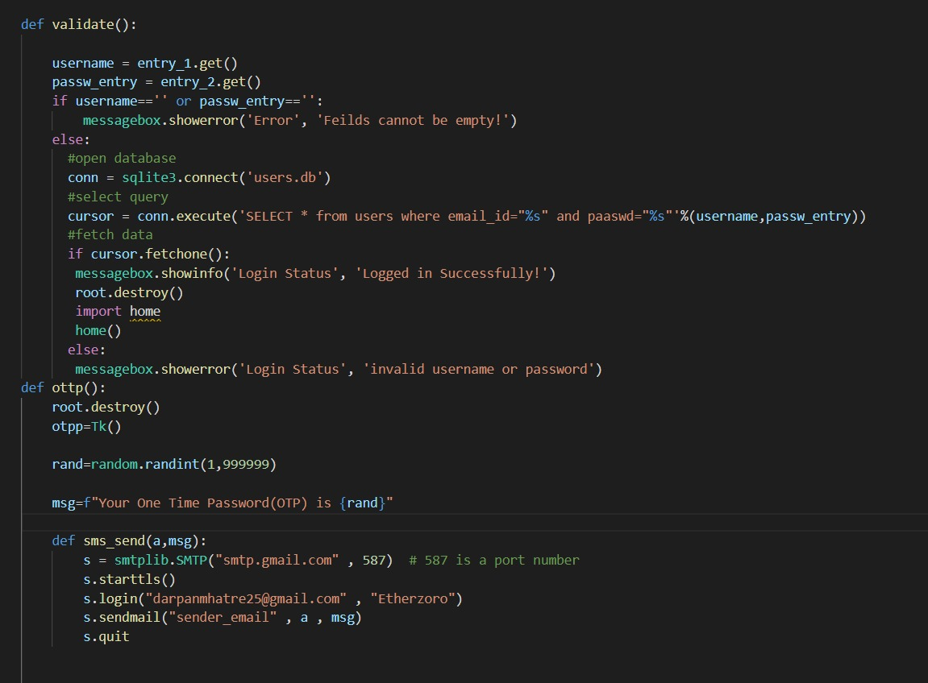

# Fig 7.2 OTP Code

A verification code will be send to user on his/her provided email id. We have used SMTP server for the same. SMTP server is Simple mail transfer protocol. it’s an application used by mail servers to send, receive, and/or relay outgoing mail between email senders and receivers. An SMTP email server will have an address (or addresses) that can be set by the mail client or application that you are using and is generally formatted as smtp.serveraddress.com. For example, the SMTP server Gmail uses is smtp.gmail.com.

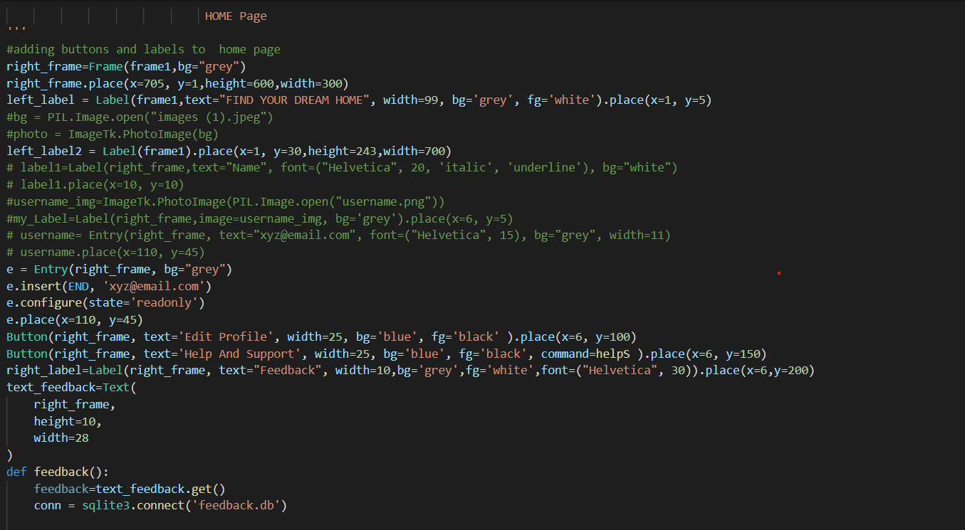

**Fig 7.3 Home Page code**

Our Homepage has feedback box where user can write a feedback which is connected to our database. We have used sqlite3 for database. To place images of different extension we have used pil module. PIL is the Python Imaging Library which provides the python interpreter with image editing capabilities. The Image module provides a class with the same name which is used to represent a PIL image.

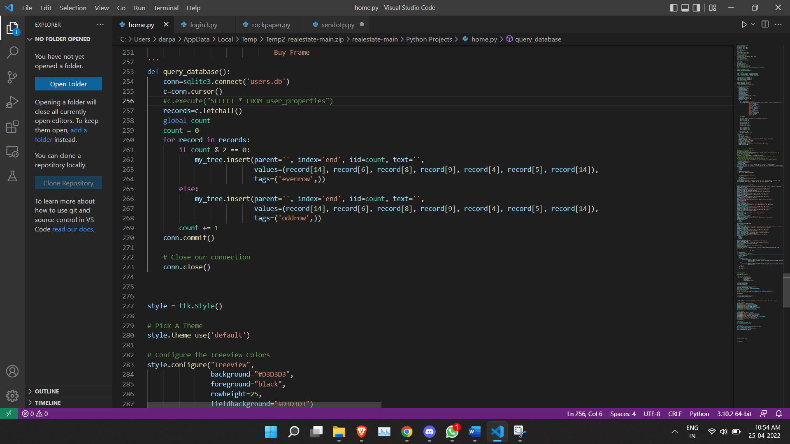

**Fig 7.4 Buy Frame**

# Data will be fetched from database and user will be able to view the properties in which he/she is interested in. we have used Treeview to display data. Treeview is a tabular representation of the data as it has all the properties of the table. Treeview has rows, columns, and heading. rows: Horizontal space determined by the data.

# Chapter 8

**Result**

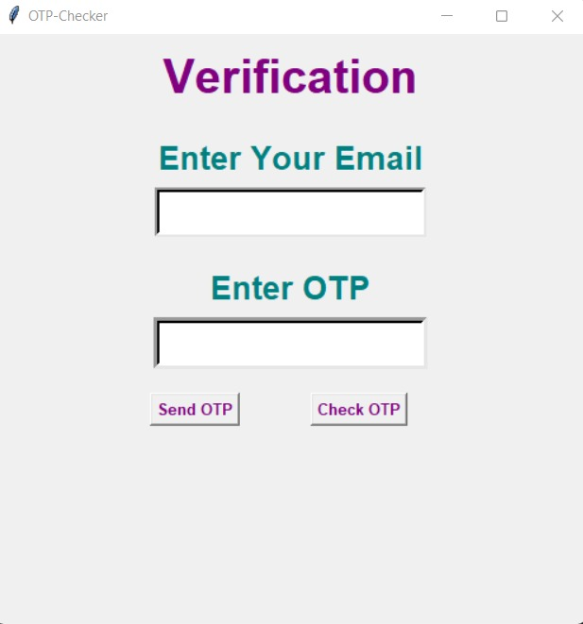

**Fig 8.1 Otp Verification**

User will get a verification otp through mail which the have to type in the above pop up box.if the otp is not send user can click on send otp and otp will be send again.

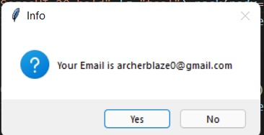

**Fig 8.2 Email confirmation**

Verification pop up window for mail id.

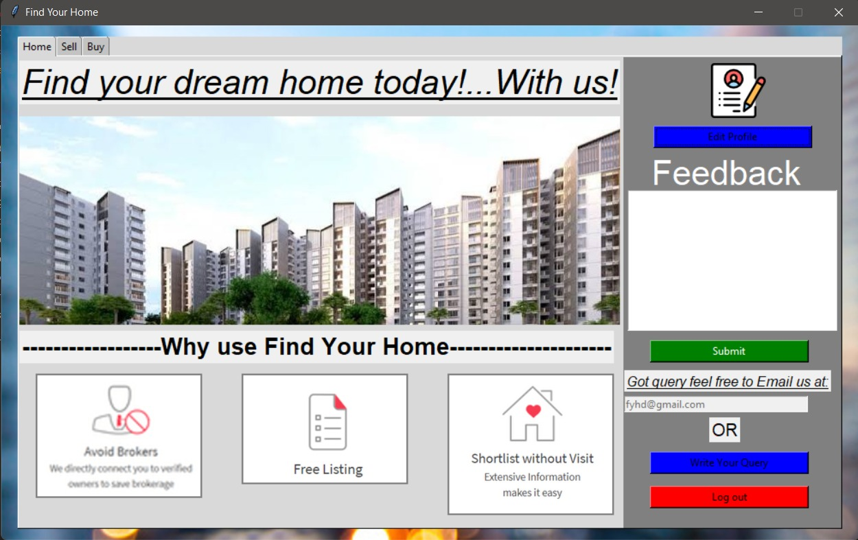

**Fig 8.3 Home Page**

Our Home page includes edit profile where user can edit or update his/ her profile. Feedback where if user wants give any suggestions they can type it in the feedback text area. Query box where if a user faces any query or problem they can mail us the same. And log out

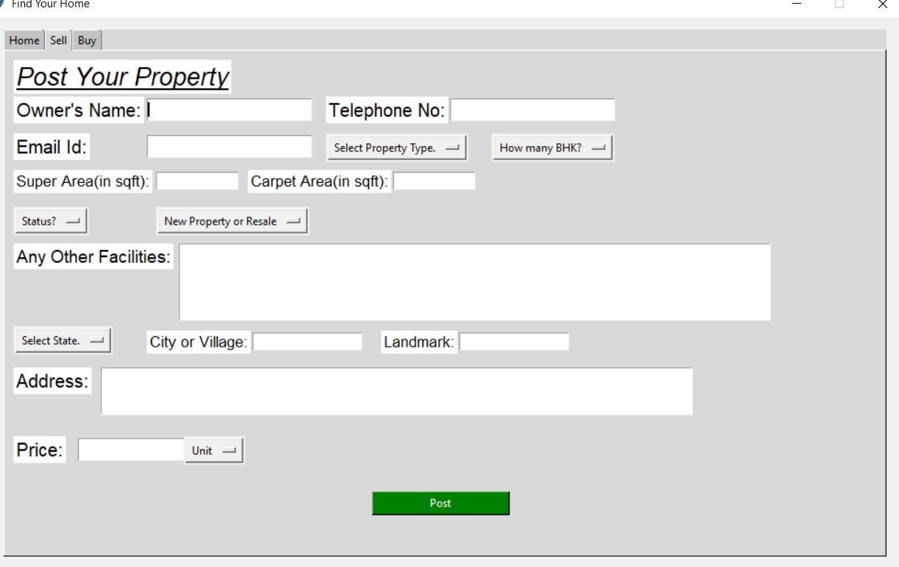

**Fig 8.4 Sell Page**

In our sell page, user has to put all the property details post it so the details will be uploaded in our database and the other user can who wants to buy the property can view the same.User can add as many properties as he wants to sell. User can also remove the properties once it is sold or the user is not interested in selling the property.

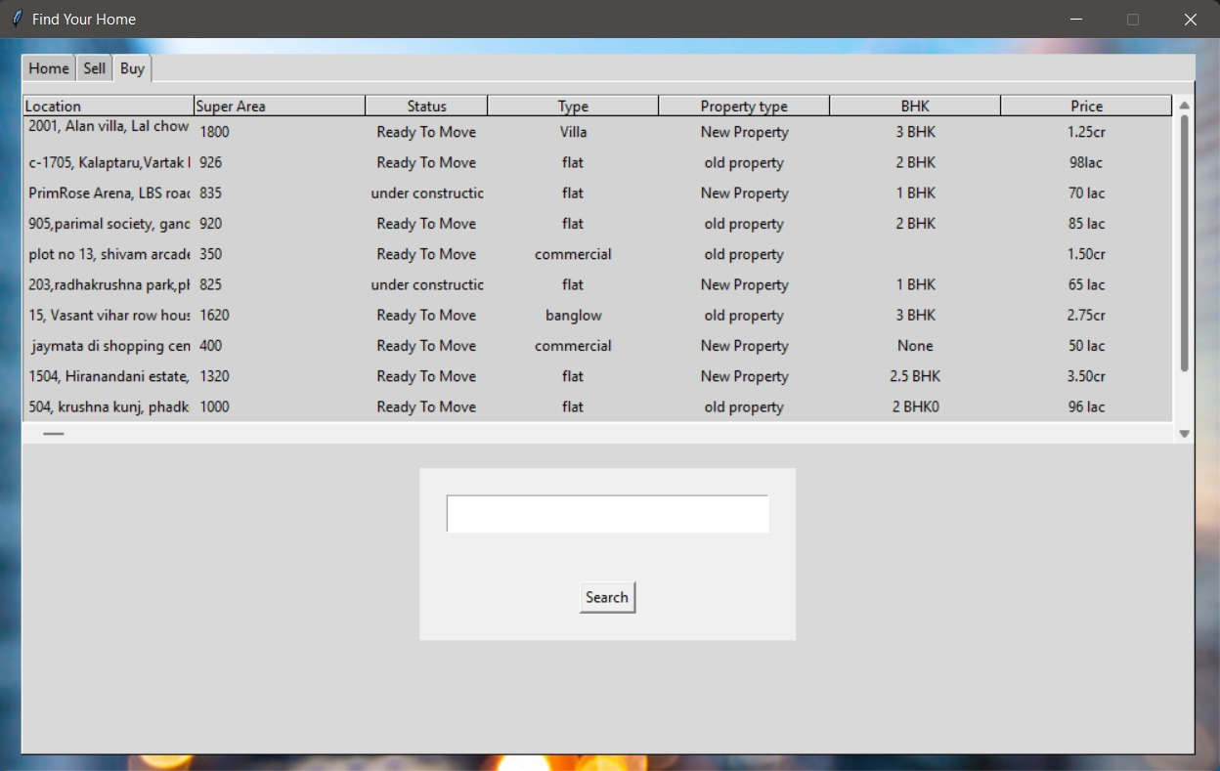

**Fig 8.5 Buy Page**

# Here, User can view the properties and can also search the properties they are interested in. The Buy page is connected to database which fetches all the entries and displays it in the search table.

# Chapter 9

**Project Scheduling Template**

|  |  |  |  |
| --- | --- | --- | --- |
| **SR. NO.** | **Group Member** | **Time Duration** | **Work Done** |
| **1** | Darpan Mhatre | 2nd week February | Implementing Registration and Search page |
| Last week of February | Testing Registration and Search page |
| **2** | Amir Madoo | 1st week of March | Implementing Home page and Database connectivity |
| 2nd week of March | Testing Home page and Database connectivity |
| **3** | Madhu Gage | 3rd week of March | Implementing Sell Page and Buy page |
| End of the march | Testing Sell Page and Buy page |
| **4** | Manashree Chavan | 1st week of April | Implementing Login Page and Commercial page |
| 2nd week of April | Testing Login Page and Commercial page |

# Chapter 10

**10.1 Conclusion:**

E-Real-estate Management system is completely free and easy to use software. It provides users with various available properties to browse through by other users on the platform and ease of search options. Our main objective was to help people to find their dream home or a place for start-ups or help someone willing to expand his/her business.

**10.2 Future Scope:**

* To make it more user friendly
* Business relationship with comprehensive online services like transport, banking etc.
* Affiliate marketing Systems, website design, and development and search engine optimization.

**References**

1. [https://docs.python.org](https://docs.python.org/)

accessed at 17/02/2022, Thursday

1. <https://www.geeksforgeeks.org/python-gui-tkinter/>

accessed at 01/03/2022, Tuesday

1. [https://www.tutorialspoint.com](https://www.tutorialspoint.com/)

accessed at 05/03/2022, Sunday

1. <https://.youtube.com/channel/UCj7i-mmOjLV17YTPIrCPkog> (Alan D Moore Codes)

accessed at 23/02/2022, Wednesday